SMART VEHICLE BLACKBOX WITH ACCIDENT DETECTION AND EMERGENCY RESPONSE

Detailed Project Report

Abstract
Road accidents often lead to delayed emergency response, increasing the risk of fatalities and severe injuries. This project presents a Smart Vehicle Blackbox system designed to improve post-accident response through automated accident detection, location tracking, and emergency alert generation.
The system uses an Arduino UNO as the central controller, an MPU6050 sensor for impact and rollover detection, a NEO-6M GPS module for obtaining accident coordinates, and a serial/GSM alert mechanism for notifying emergency contacts. Upon detecting an accident, the system immediately triggers an emergency alert, then sends a follow-up location update when GPS coordinates are available. The system then enters a lock state to preserve event information until manually reset.
This prototype acts as a low-cost intelligent automotive blackbox aimed at improving safety, reducing response time, and supporting post-accident analysis.

1. Introduction
A conventional aircraft blackbox stores flight information for analysis after incidents. Inspired by this concept, this project implements a similar blackbox idea for automobiles.
The developed system continuously monitors vehicle motion using an inertial sensor and detects:
- Sudden impacts
- Vehicle rollover
- Abnormal acceleration events
When an accident is detected:
- Immediate SOS alert is generated.
- GPS coordinates are acquired.
- Follow-up location notification is sent.
- System enters blackbox lock mode.
This reduces dependency on manual emergency reporting.

2. Problem Statement
In many accidents:
- Victims may be unconscious.
- Emergency services are not informed quickly.
- Accident location may be unknown.
- Post-crash data is often unavailable.
A low-cost automatic accident reporting system is needed.

3. Objectives
The objectives of this project are:
- Detect vehicle accidents automatically.
- Detect rollover events.
- Send immediate emergency alert.
- Provide accident location using GPS.
- Preserve accident event data.
- Develop a compact, affordable prototype.

4. System Overview

Main Functional Blocks
The system consists of:

Input Section
- MPU6050 motion sensor
- GPS satellite signals

Processing Section
- Arduino UNO
- Accident detection algorithm

Output Section
- Emergency alerts
- Location update notification
- Blackbox lock mode

5. Components Used

Hardware Components
Component | Purpose
Arduino UNO | Main controller
MPU6050 | Accident and rollover detection
NEO-6M GPS Module | Location tracking
Breadboard | Prototyping
Jumper Wires | Connections
Power Supply | System power

5.1 Arduino UNO
Acts as the brain of the system.
Functions:
- Reads sensor values
- Processes accident logic
- Generates alerts
- Controls system operation

5.2 MPU6050 Sensor
The MPU6050 is a 6-axis IMU containing:
- 3-axis Accelerometer
- 3-axis Gyroscope
Used for:
- Sudden impact sensing
- Rollover detection
- Motion anomaly detection

5.3 NEO-6M GPS Module
Provides:
- Latitude
- Longitude
- Satellite lock
- Vehicle position
Used to send accident coordinates.

6. Working Principle

Step 1 — Continuous Monitoring
The MPU6050 continuously measures:
- X-axis acceleration
- Y-axis acceleration
- Z-axis acceleration

Step 2 — Accident Detection
Acceleration magnitude is calculated:
A = √(Ax² + Ay² + Az²)
If:
- Magnitude > Threshold OR
- Tilt exceeds threshold
Then accident is declared.
Thresholds used:
- Acceleration magnitude > 25000
- |Ax| > 18000
- |Ay| > 18000

Step 3 — Immediate Alert
As soon as accident occurs:
Emergency notification is triggered instantly.
Example:
“Accident detected. SOS sent. GPS acquiring…”

Step 4 — GPS Follow-Up Alert
After GPS lock:
Coordinates are sent.
Example:
Latitude: 17.568181
Longitude: 78.431915
Maps link generated:
https://maps.google.com/?q=17.568181,78.431915

Step 5 — Blackbox Lock Mode
System halts after accident.
Purpose:
- Prevent repeated false triggers
- Preserve event state
- Mimic blackbox behavior
Manual reset required.

7. Block Diagram
+----------------+
| MPU6050 IMU |
+--------+--------+
|
|
Motion Data
|
+-------v-------+
| Arduino UNO |
| Accident Logic|
+---+-------+---+
| |
| |
+--------+ +---------+
| |
+------v------+ +------v------+
| NEO-6M GPS | | Alert Output |
+-------------+ +-------------+

8. Circuit Connections

MPU6050 to Arduino
MPU6050 | Arduino
VCC | 5V
GND | GND
SDA | A4
SCL | A5

GPS Module to Arduino
GPS | Arduino
VCC | 5V
GND | GND
TX | D4
RX | D3

GSM Module to Arduino
GSM | Arduino
VCC | 3.7V (Battery +)
GND | Common ground
TX  RX | D10  D11 (Via voltage divider)

9. Software Algorithm

Accident Detection Algorithm
- Read accelerometer values.
- Compute magnitude.
- Compare against threshold.
- If accident:
  - Trigger immediate alert
  - Wait for GPS
  - Send location update
  - Lock system

Flowchart
Start
|
Initialize Sensors
|
Monitor Motion
|
Accident Detected?
|----No----> Continue Monitoring
|
Yes
|
Send Emergency Alert
|
Acquire GPS Coordinates
|
Send Location Update
|
Lock System
|
End

10. Features Implemented

Accident Detection
Using acceleration magnitude and rollover threshold.

Rollover Detection
Detects abnormal vehicle orientation.

Two-Stage Alerting
Stage 1: Immediate emergency notification.
Stage 2: Location update after GPS lock.

Blackbox Locking
System halts after event.

11. Code Logic Highlights

Acceleration Magnitude Logic
Uses sensor fusion:
- Impact spike detection
- Tilt detection
This reduces false alarms.

Two-Stage Emergency Protocol
Unlike waiting for GPS before alerting, this project:
- Alerts immediately
- Updates location later
Faster response.

12. Results

Observed Results
System successfully:
- Detected accident simulations
- Detected rollover events
- Obtained GPS lock
- Generated emergency alerts
- Produced live location coordinates
- Entered blackbox lock mode

Sample Output
ACCIDENT DETECTED
EMERGENCY ALERT SENT
SOS Sent
GPS Acquiring...
LOCATION UPDATE SENT
Coordinates:
17.568181,78.431915
System Locked
Manual Reset Required
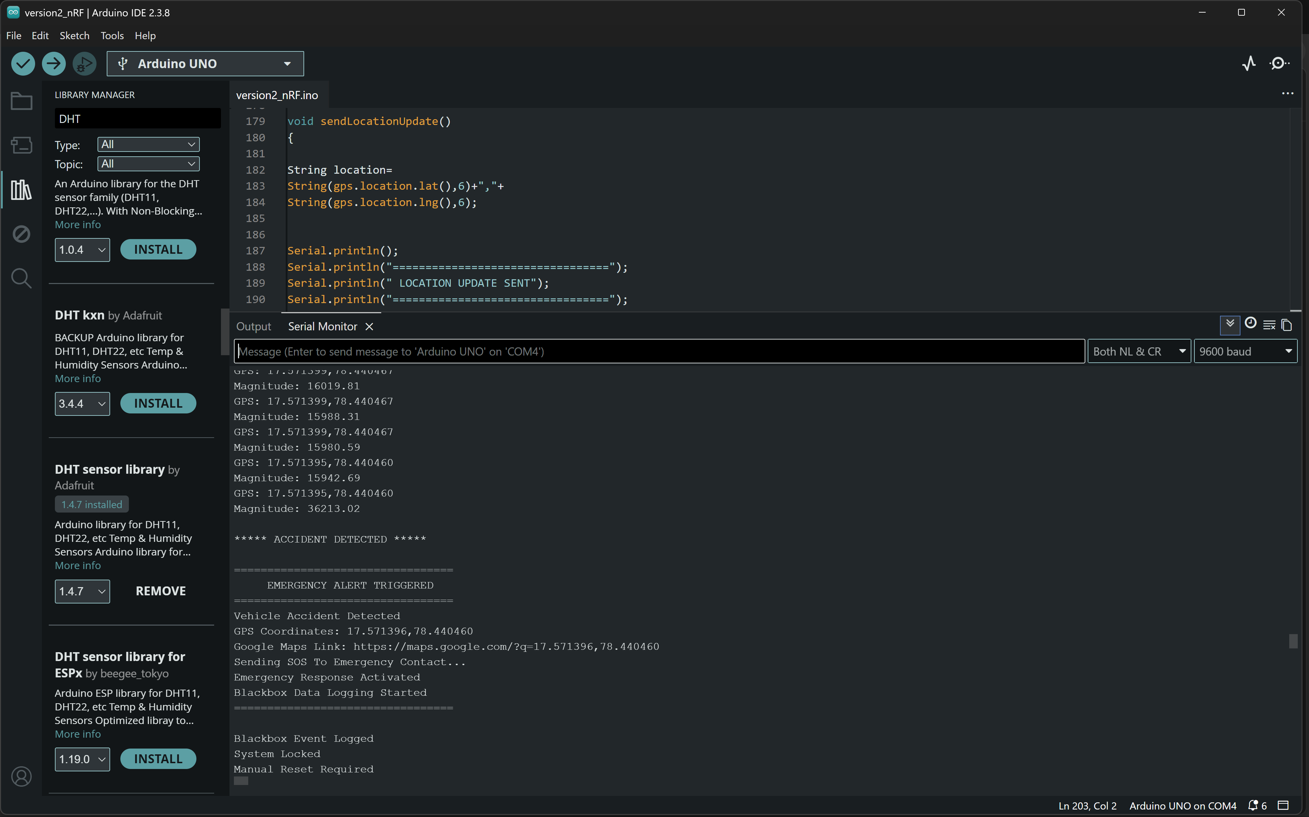
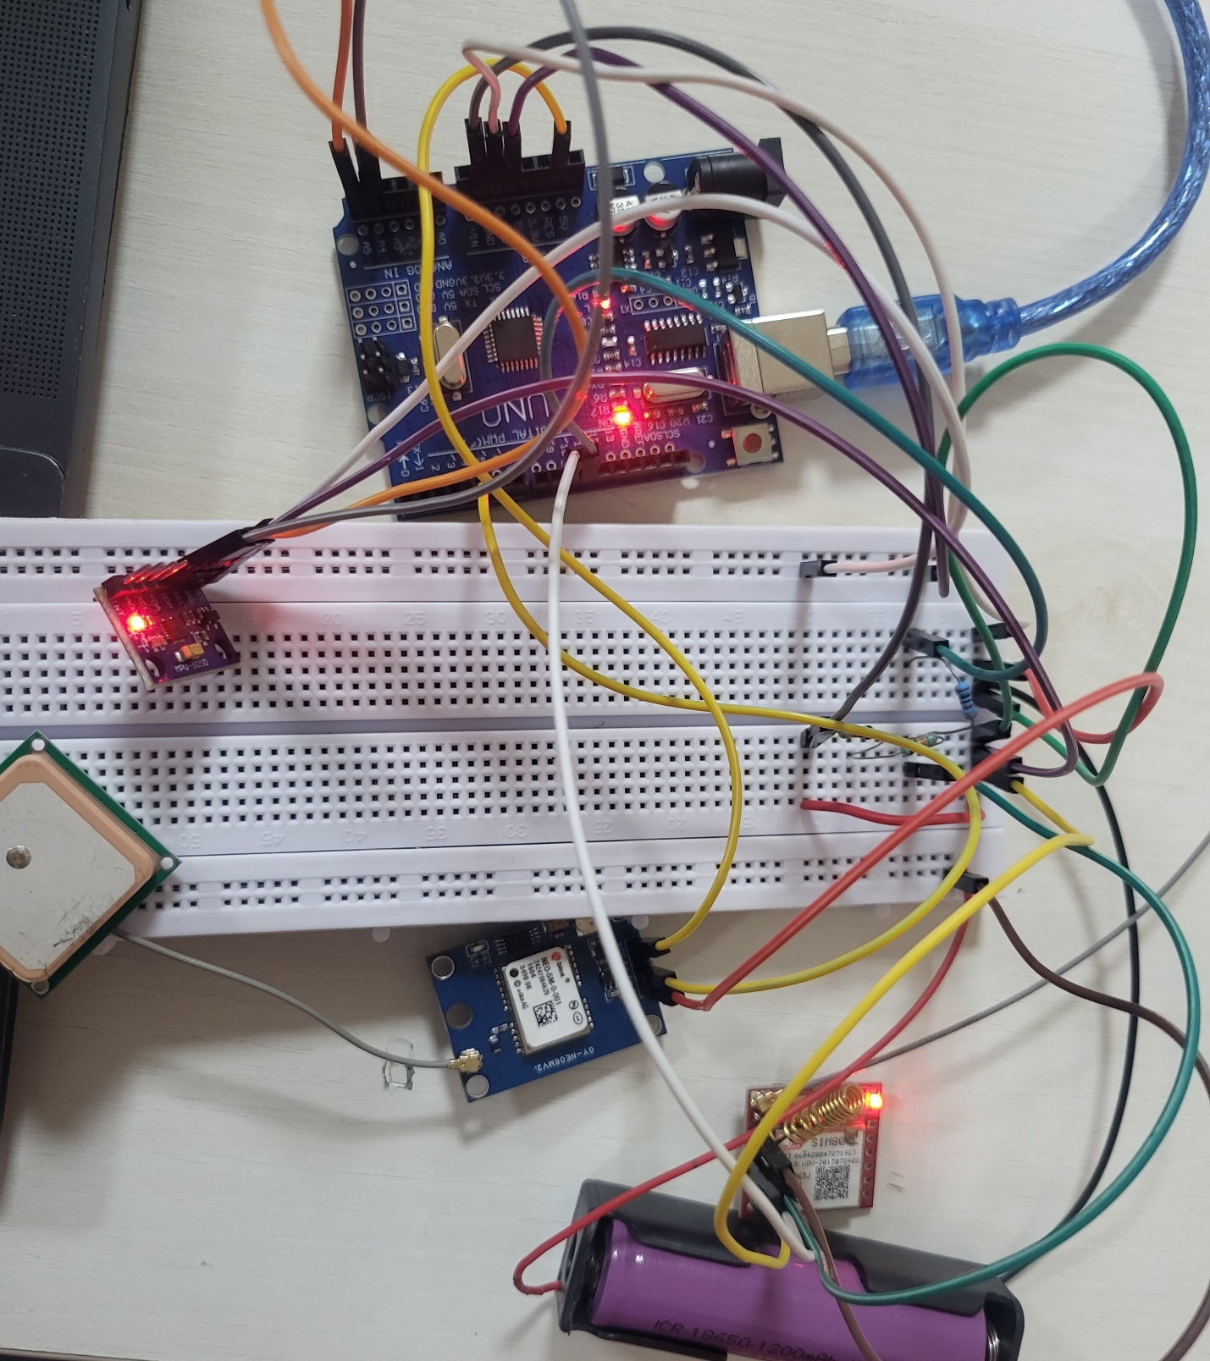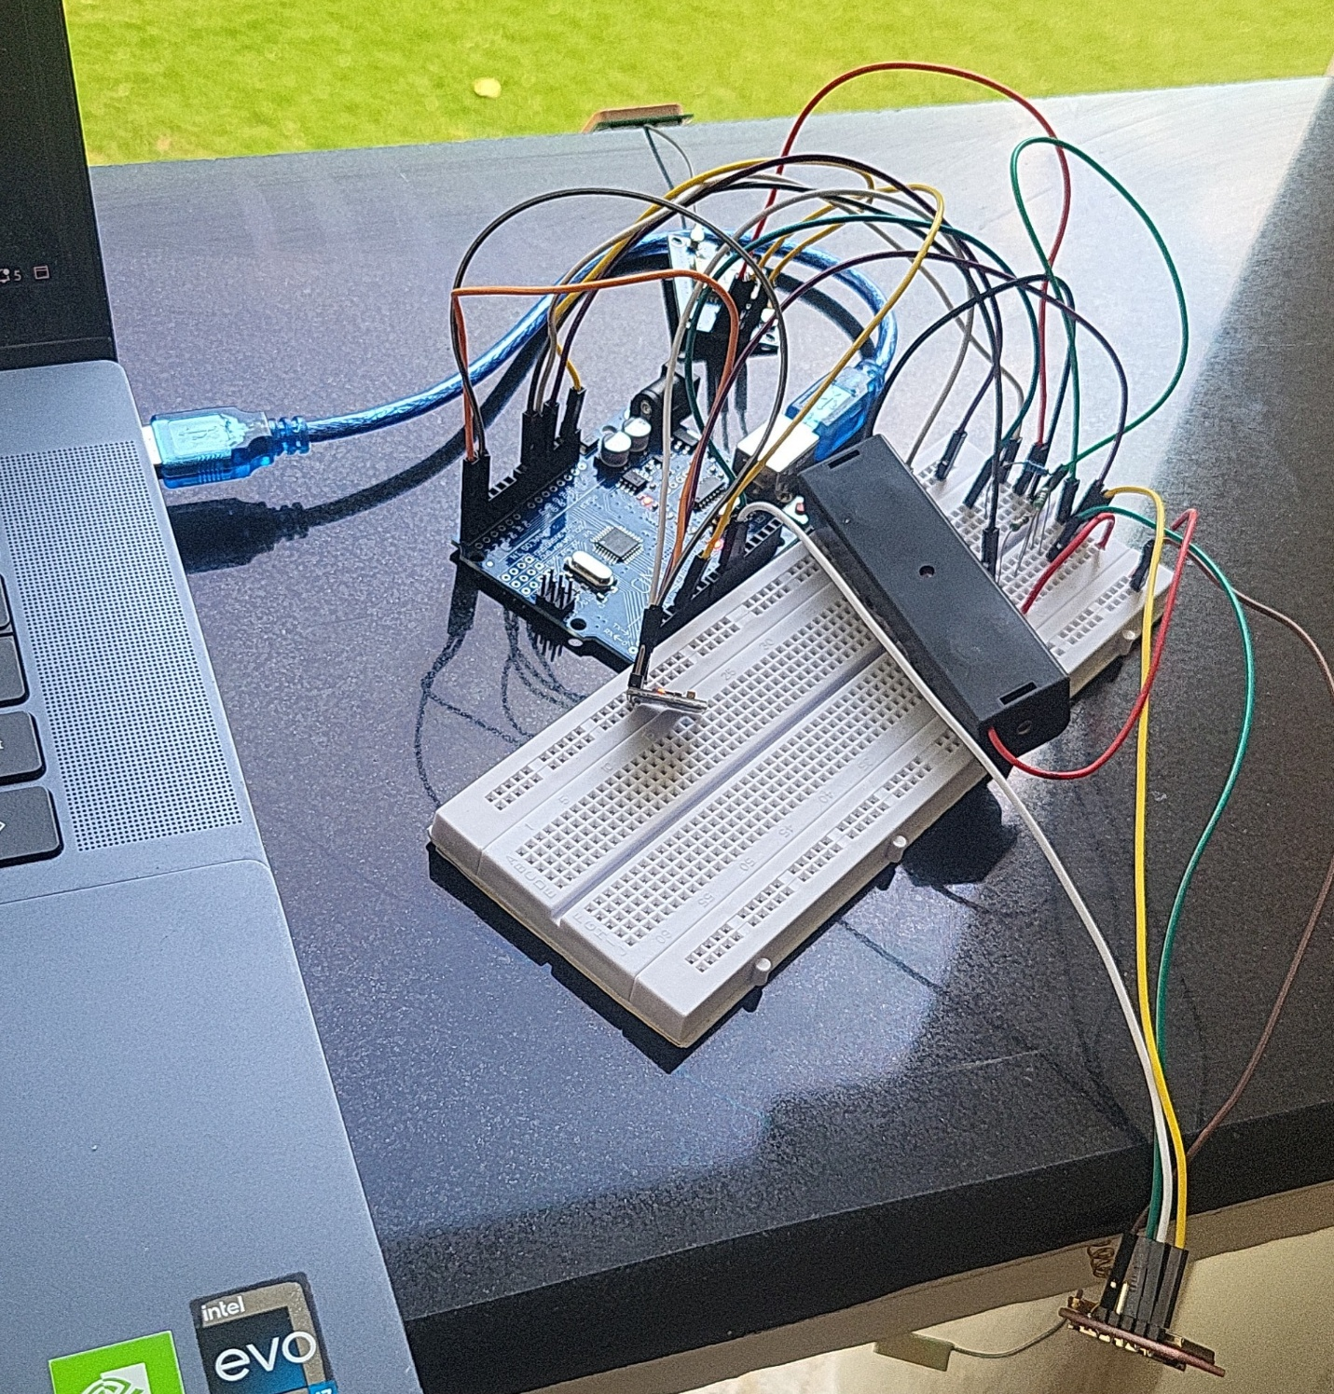

13. Limitations
- GPS requires open sky for lock.
- Thresholds may need calibration for different vehicles.

